Option 1

Steps to Perform
One time Scheduler via Upload Zip file
- Prepare your code locally on vs code and confirm its successful execution
- Replace input and output file from locally to GCP and confirm its successful execution
- Make zip of project folder
- Login to GCP
- Open Cloud Shell
- Command – ls, to check the existing project there
  - rm -rf filename to remove the file from there
- Upload Your Project, and confirm with command ls if it appear there
- Unzip your folder- unzip forecast_project.zip
- Go inside the project folder - cd forecast_project
- Create Artifact Registry (If Not Created)
- Go to Search – Artifact Registry – Create Registry – and name It - forecast-repo
- Run below command on cloud shell and it must say, repo already exist
gcloud artifacts repositories create forecast-repo \
--repository-format=docker \
--location=asia-south1
- Build docker container on repo by hitting below command, Interanally it will perform all steps which we write in docker file.
gcloud builds submit \
--tag asia-south1-docker.pkg.dev/project-cfd0578a-68eb-49ae-82d/forecast-repo/forecast-app
- Create Cloud Run Job - Cloud Run → Jobs → Create Job
- You may execute the job instantly to check it everything is working fine.
- You can schedule the job as well

What Happened Internally
Sachin — this is an excellent question.
You’re now asking about what actually happens internally, not just “does it work.” That’s how you move from user → engineer.
Let’s break this down very clearly and calmly.

🔹 Step 1 — What Does This Command Actually Do?
gcloud builds submit \
--tag asia-south1-docker.pkg.dev/project-cfd0578a-68eb-49ae-82d/forecast-repo/forecast-app
When you run this inside Cloud Shell:

✅ 1️⃣ It uploads your current folder to Cloud Build
Cloud Build now receives:
- Dockerfile
- main.py
- requirements.txt
- all your project files

✅ 2️⃣ Cloud Build looks for a Dockerfile
It finds:
FROM python:3.10-slim
WORKDIR /app
COPY . .
RUN pip install -r requirements.txt
CMD ["python", "main.py"]

✅ 3️⃣ Cloud Build runs a Docker build internally
It effectively executes:
docker build -t forecast-app .
But this happens on Google’s managed infrastructure, not your laptop.

✅ 4️⃣ A Docker image is created
This image now contains:
- Linux base image
- Python installed
- All pip packages installed
- Your full code copied
- Startup command defined
This image is now a self-contained environment.

✅ 5️⃣ That image is pushed to
👉 Google Artifact Registry
So Artifact Registry now stores:
forecast-app:latest
That is just a stored container image.
Nothing is running yet.

🔹 Step 2 — What Happens When You Create a Cloud Run Job?
You go to
👉 Cloud Run
And create a Job using that image.
Now Cloud Run knows:
“When this job executes, start a container using this image.”

🔹 Step 3 — What Happens When Scheduler Triggers?
When
👉 Cloud Scheduler
triggers the job:
Here’s what happens internally:

🟢 1️⃣ Cloud Run pulls the image from Artifact Registry
It downloads the stored Docker image.

🟢 2️⃣ Cloud Run starts a container from that image
Important distinction:
- Image = blueprint
- Container = running instance
Cloud Run creates a container instance from the image.

🟢 3️⃣ It executes the command in Dockerfile
Your Dockerfile contains:
CMD ["python", "main.py"]
So when container starts:
It runs:
python main.py
So to answer your question directly:
Does it run container or main.py?
It runs a container.
Inside that container, main.py runs.

🟢 4️⃣ Your script executes
Inside container:
- Connects to Cloud Storage
- Downloads stock_data.csv
- Runs ARIMA
- Uploads forecast file

🟢 5️⃣ Container exits
After script finishes:
Container stops.
Billing stops.
Nothing stays running.

🔥 Important Concept
Docker is NOT running main.py directly.
It ensures:
- Same Python version
- Same pip versions
- Same OS environment
- Same dependency structure
So yes — you said it correctly:
objective of docker is to install everything with same version on other machine or cloud so things wont break.
That is exactly correct.

🧠 Clear Mental Model
Dockerfile → builds Image
Image → stored in Artifact Registry
Cloud Run → creates Container from Image
Container → executes main.py

🔎 So What Is Actually Running?
When scheduler runs:
- A new container instance is created
- It runs main.py
- It exits
Every run is isolated.
Every run is clean.
No memory carried forward.

Option 2
Now assume, if I make few changes to main.py file I need to repeat every step again. as we discussed last time this is good for learning and check it everything is running fine but not for production set up. Now with this I wants to proceed with docker image. I create a docker image here and put it on artifact registry, so now tell me this step. As per my understanding, now instead of zip and upload on cloud shell, I can build a docker image on my local system, I can upload it on artefact registry as cloud build internally create docker file but I have already created so that step will be gone. and then I can again set up schedule job to run for new artefact repo. what’s your thought? M I missing something’s any step here, or give me the correct steps for this

🎯 What You Want Now
Instead of:
Upload ZIP → Cloud Build builds image
You want:
Local VS Code
→ `docker build` locally
→ Push image to **Google Artifact Registry**
→ Cloud Run Job uses that image
→ Scheduler runs job

This is cleaner and more realistic.

And yes — this is the correct next step.

Steps and Description

1️⃣ Build Docker image locally
2️⃣ Run it locally to confirm
3️⃣ Push it to **Google Artifact Registry**

No cloud confusion. Just clean developer flow.
# 🟢 PHASE 1 — Build Docker Image Locally
### ✅ Step 1 — Go to Project Folder
Open terminal inside:
```bash
cd path\to\forecast_project
```
Confirm you see:
```bash
dir
```

You must see:

```
Dockerfile
main.py
requirements.txt
...
```
### ✅ Step 2 — Build Docker Image
Run:
```bash
docker build -t forecast-app .
```
Explanation:
* `-t forecast-app` → image name
* `.` → build using current folder
* Docker will read your Dockerfile

If successful, you’ll see:
Successfully built ...
Successfully tagged forecast-app:latest
```

Now you have a local Docker image.
# 🟢 PHASE 2 — Run Docker Image Locally

Now test it before pushing to cloud.
### ✅ Step 3 — Run Container
```bash
docker run forecast-app
```
Since your Dockerfile likely has:

```dockerfile
CMD ["python", "main.py"]
```
It will:
* Start container
* Run main.py
* Connect to GCP bucket
* Upload forecast file
* Exit
### ⚠ If You Get Credential Error
Because this is local Docker, you may need to pass credentials.
If your local machine already has:
```bash
gcloud auth application-default login
```
Then it should work.
If not, you may need to mount credentials file — but try first without that.
---
### ✅ Confirm Success
Check your Cloud Storage bucket in:
👉 **Google Cloud Storage**
You should see new forecast file.
If yes → container is good.
# 🟢 PHASE 3 — Push Image to Artifact Registry
Now we move image to cloud.
### ✅ Step 4 — Login & Set Project
gcloud auth login
gcloud config set project project-cfd0578a-68eb-49ae-82d
gcloud auth configure-docker asia-south1-docker.pkg.dev
### ✅ Step 5 — Tag Image for Artifact Registry
Your local image is:
```
forecast-app
```
Now tag it:
docker tag forecast-app asia-south1-docker.pkg.dev/project-cfd0578a-68eb-49ae-82d/forecast-repo/forecast-app:latest
This creates a new alias pointing to same image.
---
### ✅ Step 6 — Push Image
```bash
docker push asia-south1-docker.pkg.dev/project-cfd0578a-68eb-49ae-82d/forecast-repo/forecast-app:latest
```
Now image is stored in Artifact Registry.
# 🟢 FINAL STEP — Update Cloud Run Job
# 🧠 Mental Model Summary
Dockerfile
→ `docker build` → Image
Image
→ `docker run` → Container (local test)
Image
→ `docker push` → Artifact Registry
Cloud Run Job
→ Pull image → Start container → Run main.py

Doubt
I have one question here, the same docker file appear on my docker desktop once again, so I can see 2 docker file now, one with forecast app and other with complete name that we push to artifact. Also Can I see this docker image on my OS as well like I can see on docker desktop on, so when I run this docker build -t forecast-app ., where it will get stored on OS? and when we are pushing this to GCP , from where it will copy and move to artifact
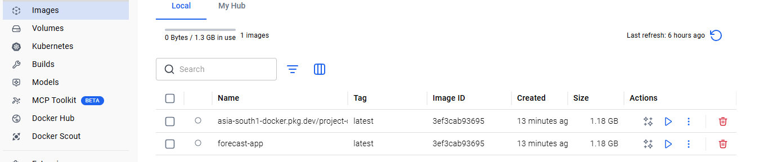
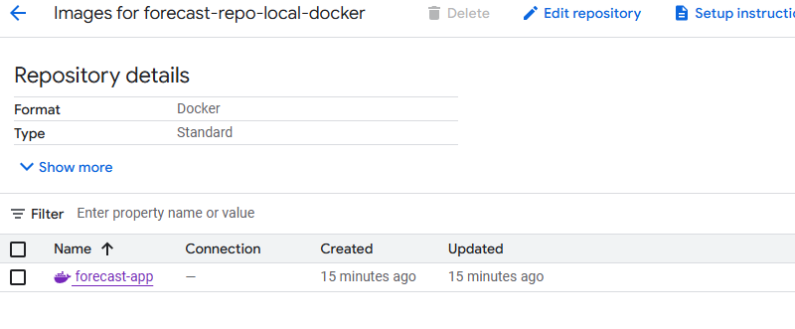
Sachin — these are very good container-level questions 👏
Now we’re talking about how Docker actually works internally.

Let’s clear everything step-by-step.

# 🔹 1️⃣ Why Do You See Two “Images” in Docker Desktop?

You built locally:
docker build -t forecast-app .

Then you tagged:
docker tag forecast-app \
asia-south1-docker.pkg.dev/.../forecast-app:latest

Important:
👉 You did NOT create two different images.
👉 You created **two tags pointing to the same image**.

Think of it like this:

Image ID: abc123
├── forecast-app:latest
└── asia-south1-docker.pkg.dev/.../forecast-app:latest

Both names point to the same underlying image.
Docker Desktop shows both tags.
So don’t worry — it’s not duplicated.
---

# 🔹 2️⃣ Where Is The Docker Image Stored On Your OS?
When you run:
docker build -t forecast-app .

Docker:
1. Reads Dockerfile
2. Builds image layers
3. Stores image inside Docker’s internal storage

Important:
👉 It is NOT stored as a .zip file
👉 It is NOT stored as a visible folder
👉 It is stored inside Docker Engine’s image cache

On Windows with Docker Desktop + WSL:
It is stored inside the Docker VM (WSL2 virtual disk).
You normally don’t browse it directly.

# 🔹 3️⃣ How Does Docker Push To GCP?

When you run:
docker push asia-south1-docker.pkg.dev/...

Here’s what happens:
1️⃣ Docker looks in its **local image cache**
2️⃣ Finds the image with that tag
3️⃣ Authenticates to **Google Artifact Registry**
4️⃣ Uploads image layers over HTTPS

It does NOT:
* Copy from your file system
* Read from project folder again
* Rebuild anything

It uploads from Docker’s internal image storage.
# 🔹 4️⃣ What Actually Gets Uploaded?
Docker images are layered.
Example layers:
* Python base image
* Installed pip packages
* Your app code

Docker checks:
👉 If a layer already exists in registry
It doesn’t upload it again.

Only new layers get uploaded.

This makes push efficient.
---

# 🔹 5️⃣ After Pushing, What Exists Where?
On your laptop:

* Docker image stored locally
* Tagged twice

On GCP:

* Same image stored in Artifact Registry

They are independent copies.

Deleting local image does NOT delete registry image.
---
# 🔹 6️⃣ Can You See Image On OS Directly?

Not really in a normal readable format.

But you can inspect it:
docker images
To see image IDs.
Or:
docker inspect forecast-app
To see metadata.
But the raw storage is managed by Docker Engine
# 🔹 7️⃣ When Cloud Run Executes Job
When Cloud Run runs:
1️⃣ It pulls image from Artifact Registry
2️⃣ Stores it in Google’s container runtime
3️⃣ Starts a container instance
4️⃣ Executes CMD from Dockerfile
5️⃣ Stops container

It does NOT access your laptop.
---
# 🧠 Mental Model

Docker build
→ Stores image inside Docker Engine

Docker tag
→ Adds new label to same image

Docker push
→ Uploads image layers to registry

Cloud Run
→ Pulls image from registry
→ Starts container
→ Runs main.py
---
# 🔥 Important Takeaway
You are not copying files manually.
You are moving **container images**, not source code.
Docker abstracts everything into image layers.

Option 3

